Services & Dependency Injection
Task 1: Create and Use a Course Service.
Goal: Build a CourseService that provides course data to multiple components.
Generated a service for courses and also created couse-summary-widget
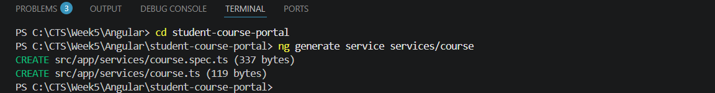Course.ts:
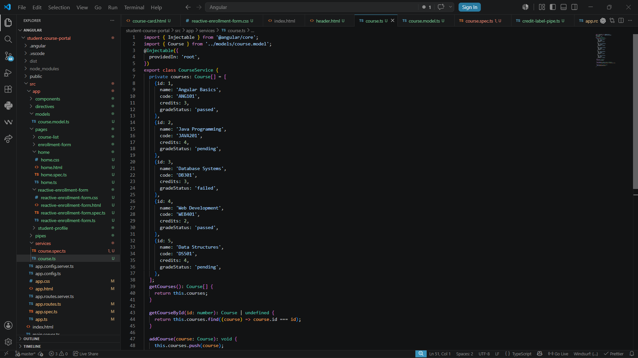
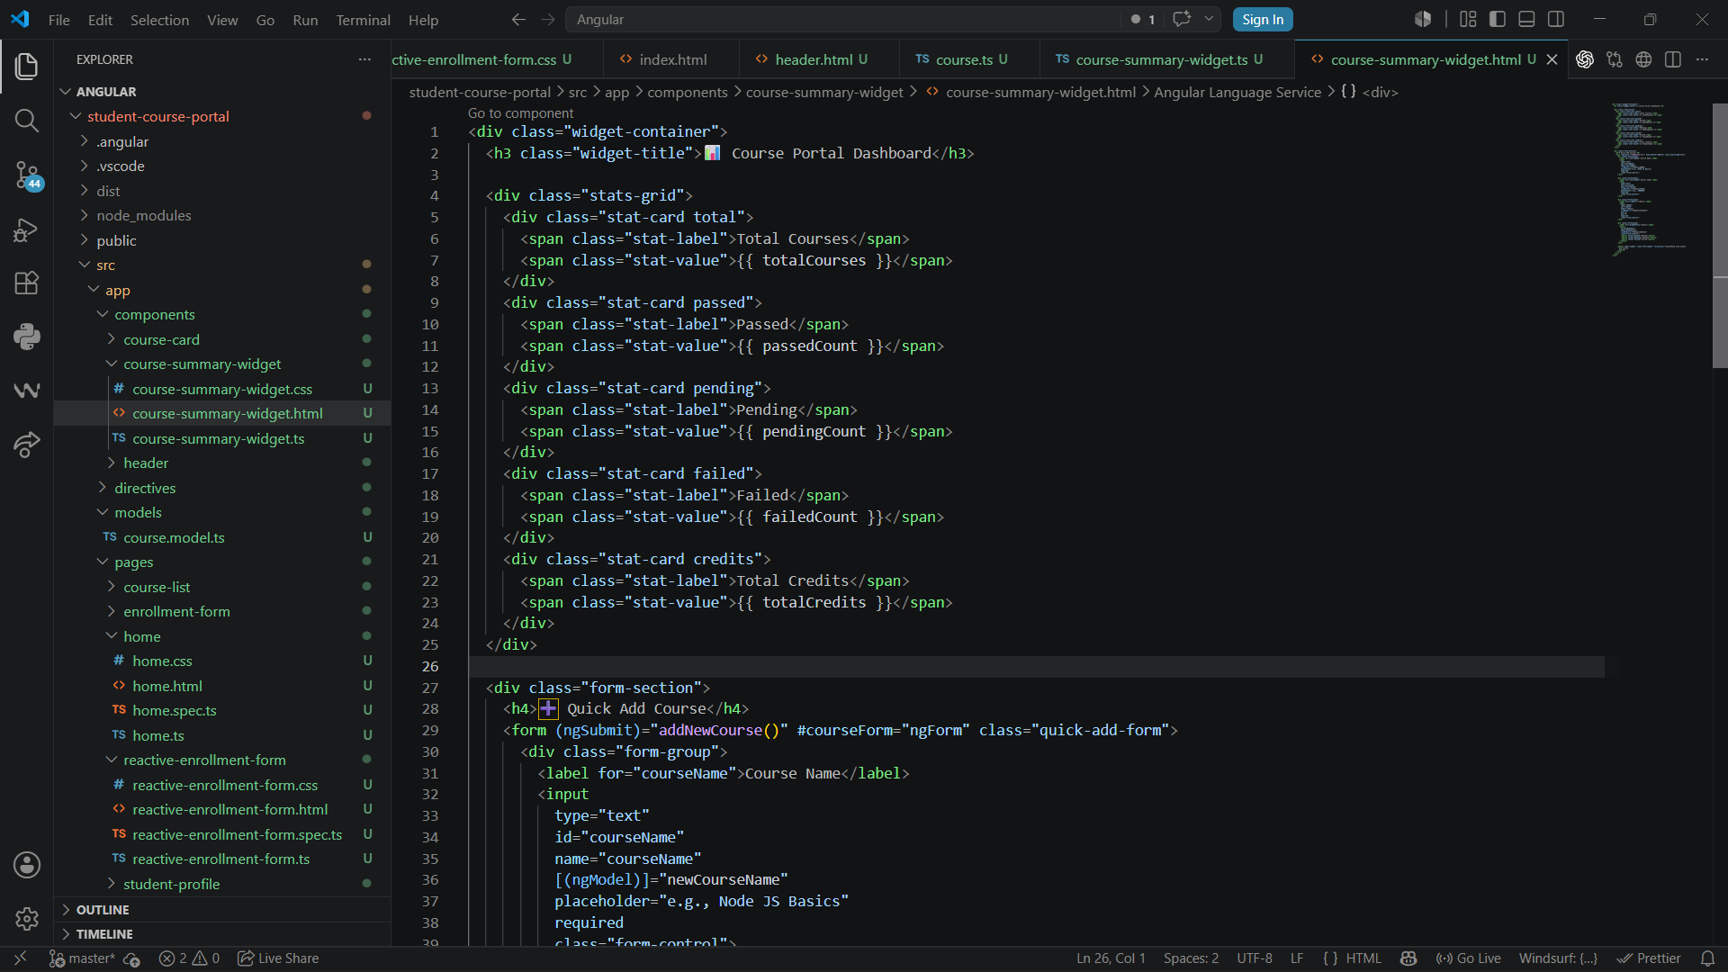
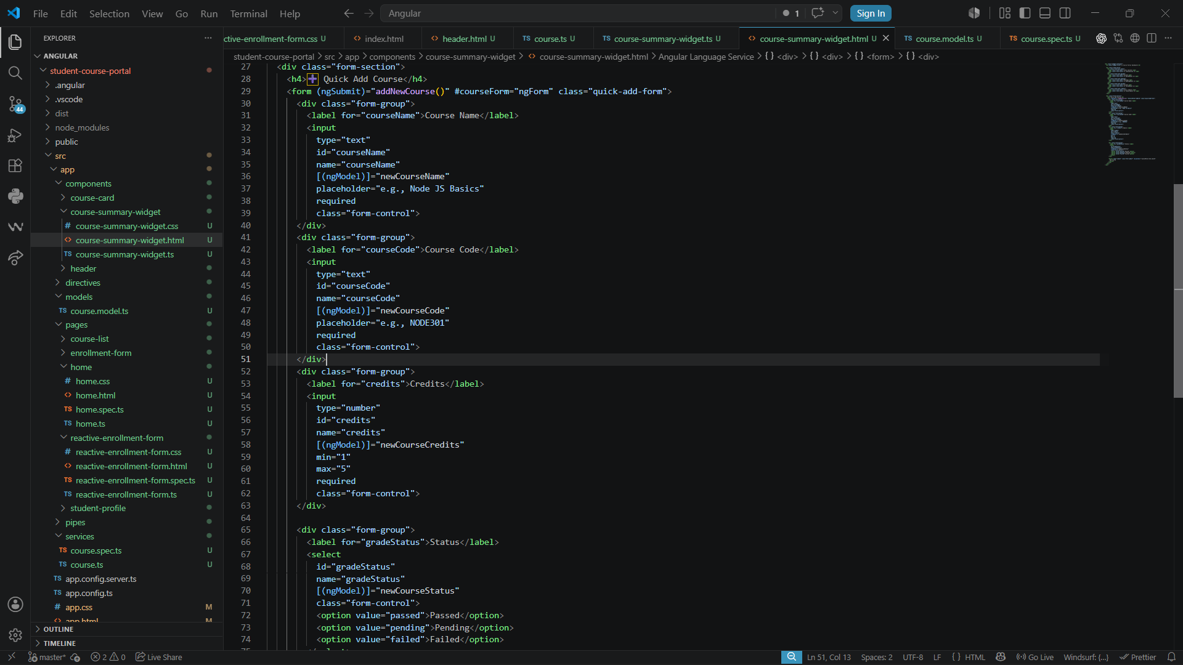
Course-summary-widget.ts
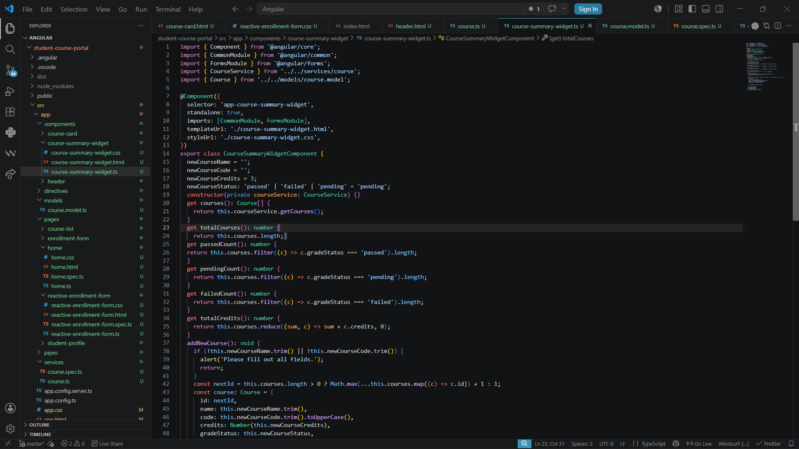

Output:
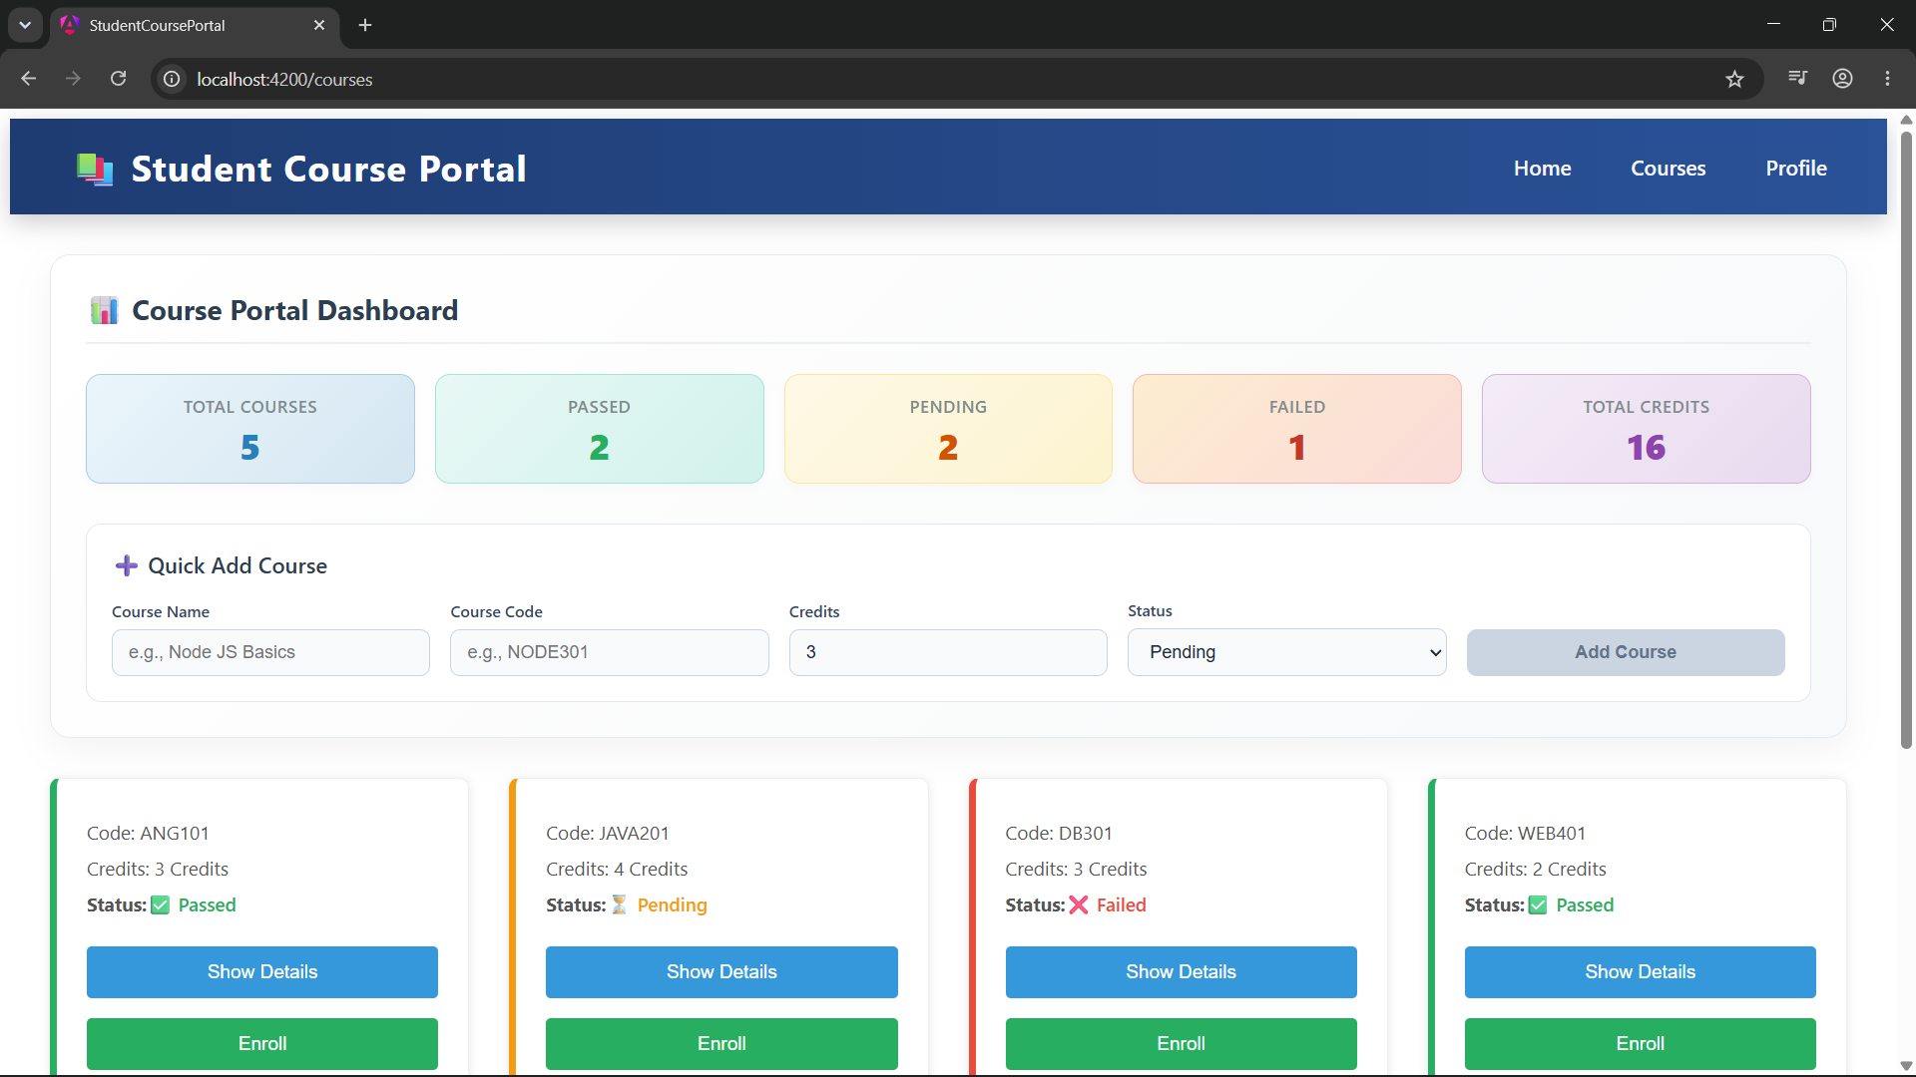

Adding New Course to the DashBoard

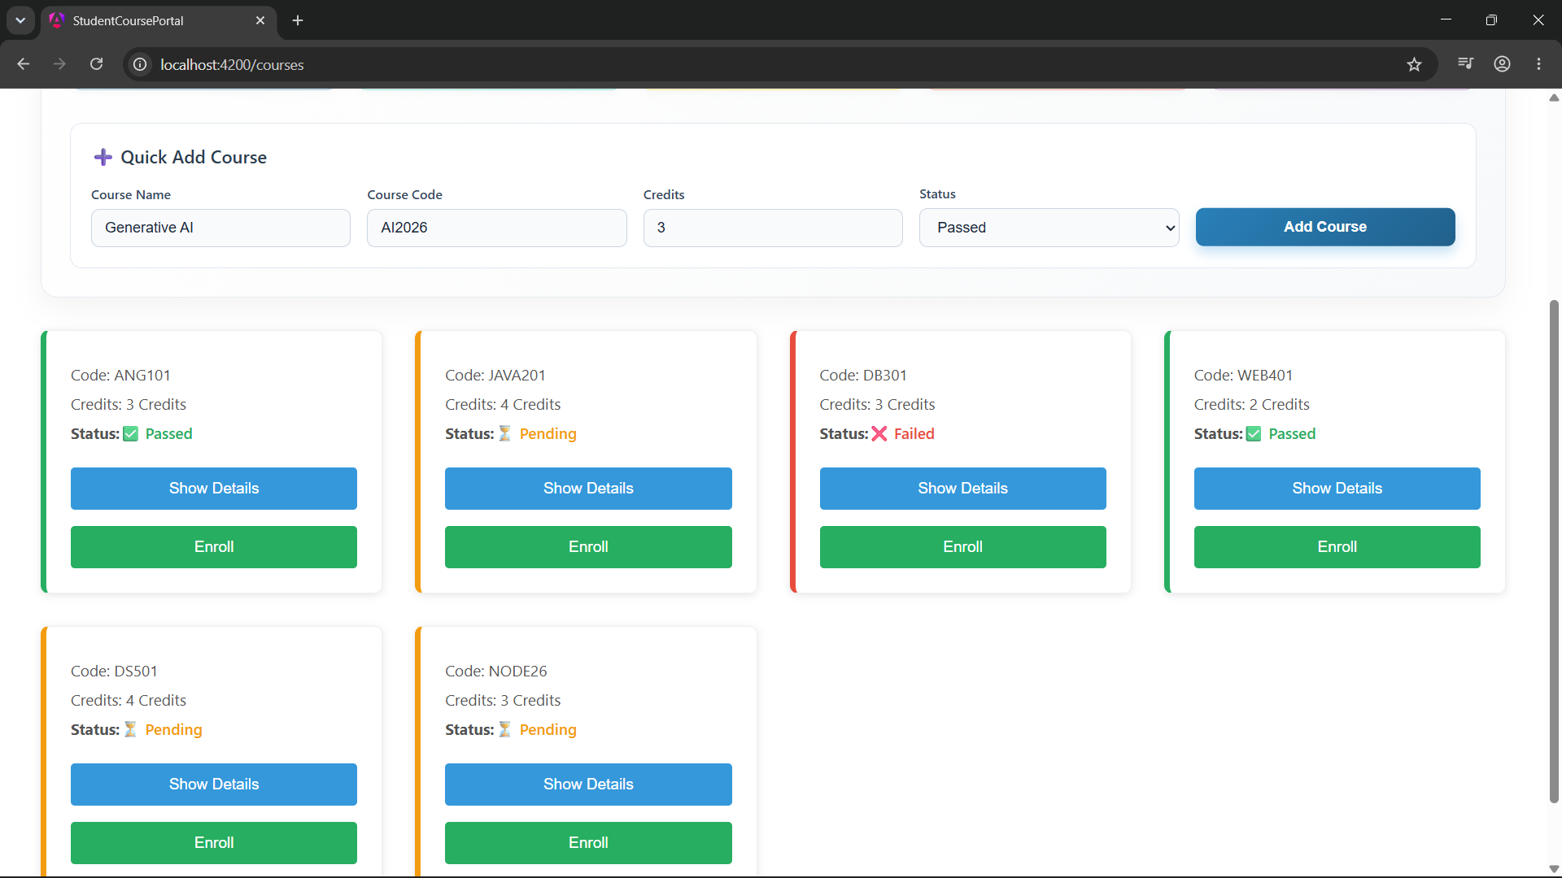

New Course Added and the data are changed based on that
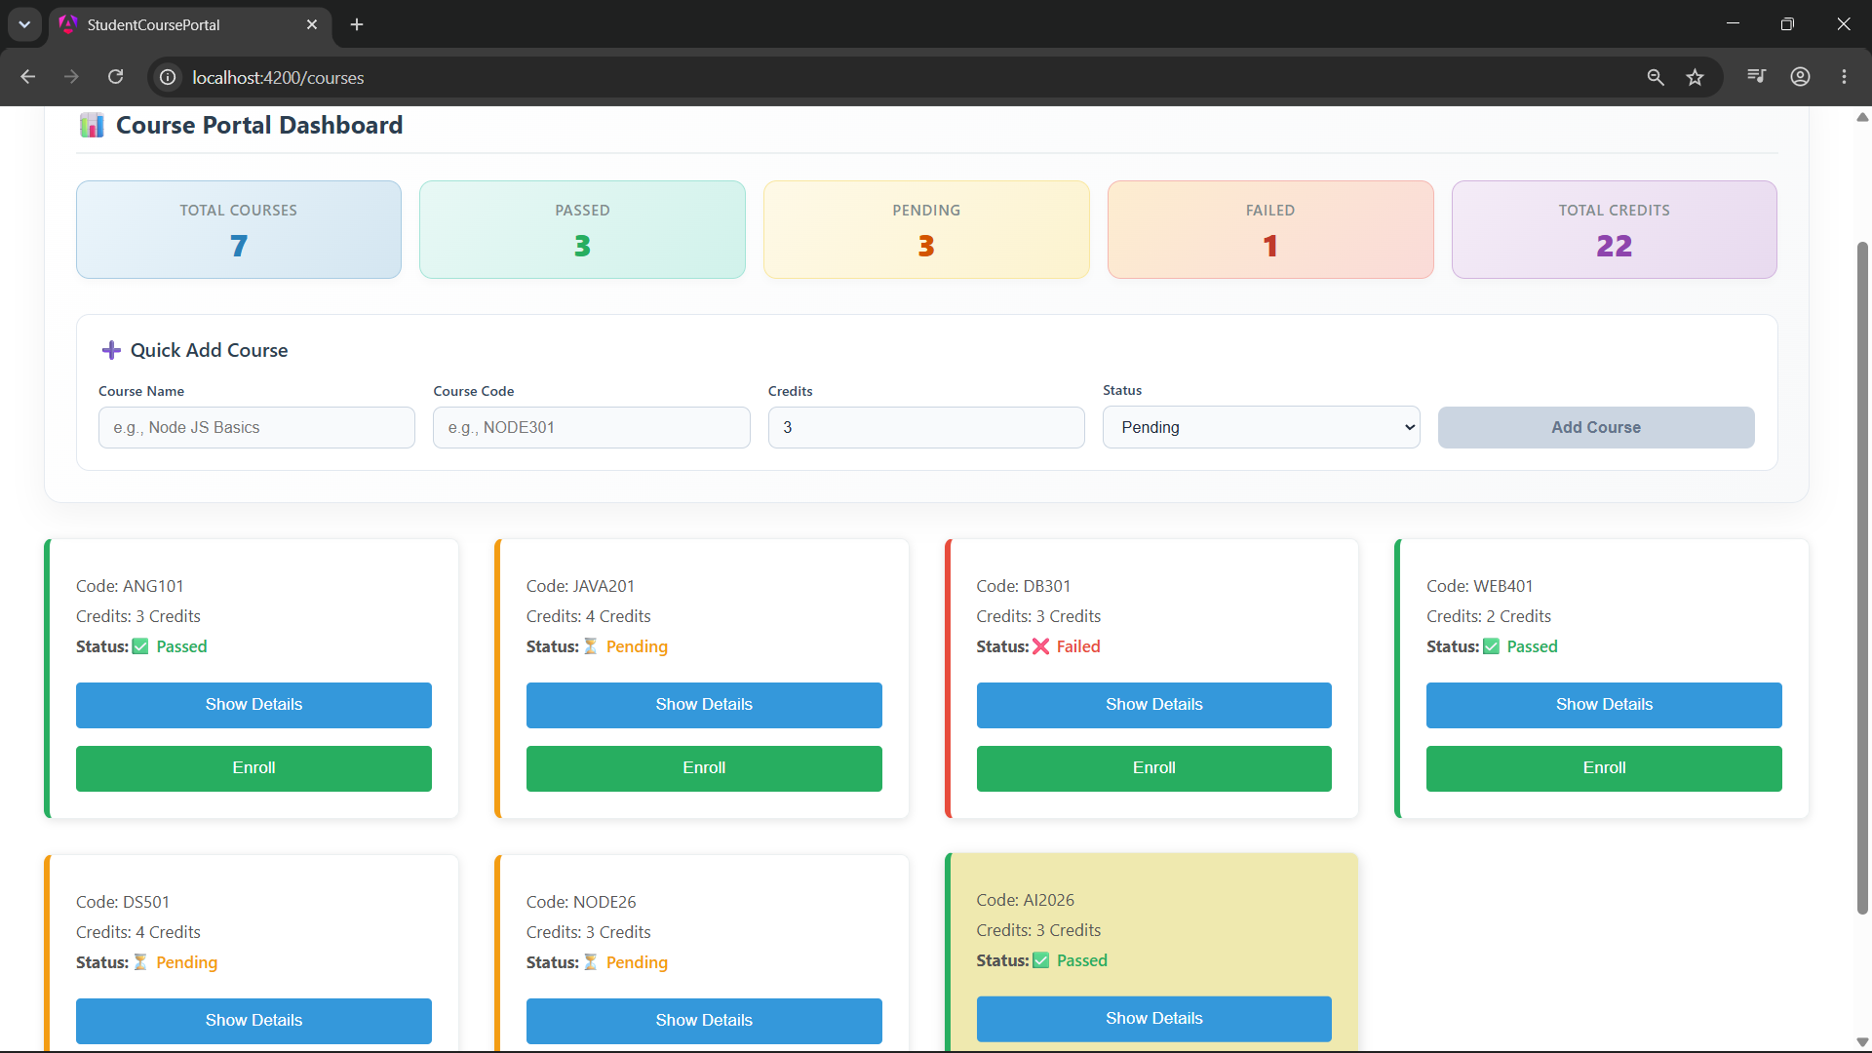
Task 2: Enrollment Service and Hierarchical DI
Goal: Create an EnrollmentService and demonstrate the DI hierarchy with component-level providers.
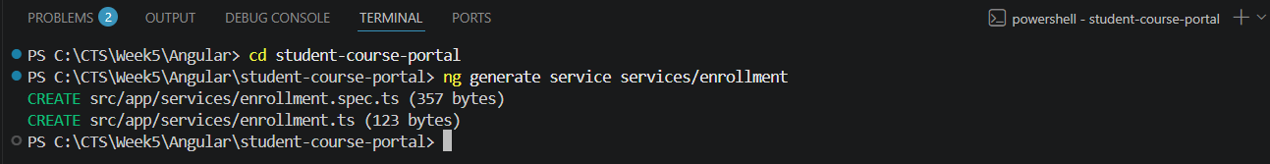
enrolment.ts:
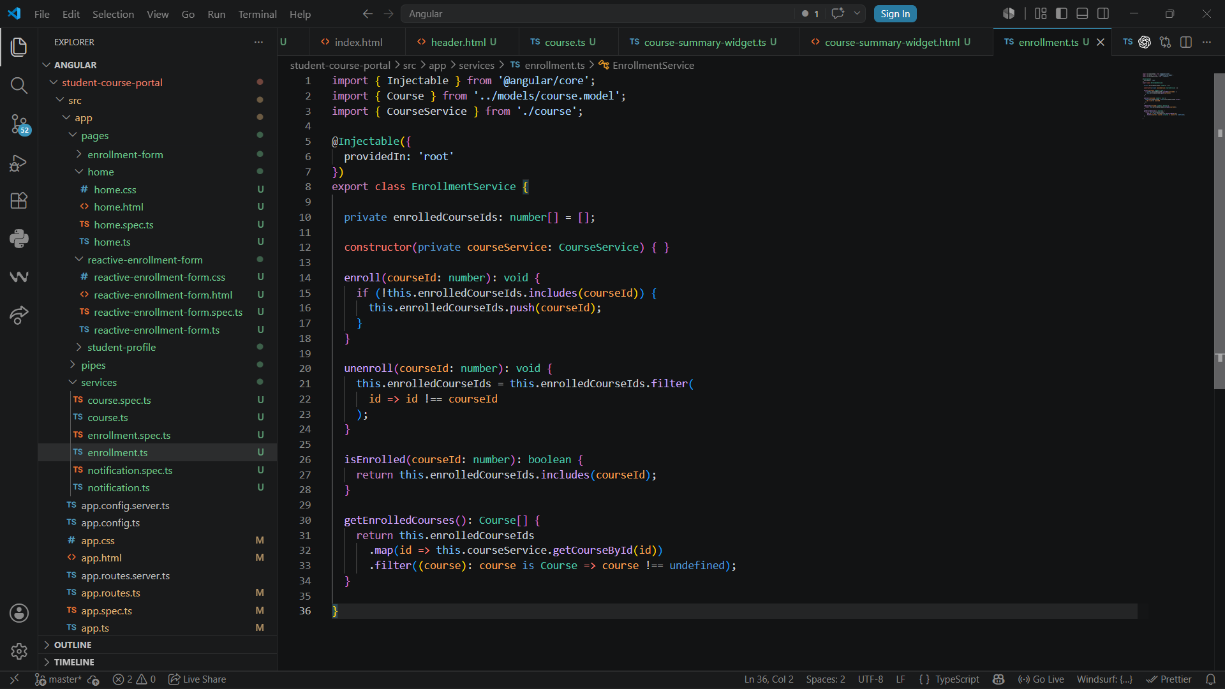
course-card.ts:
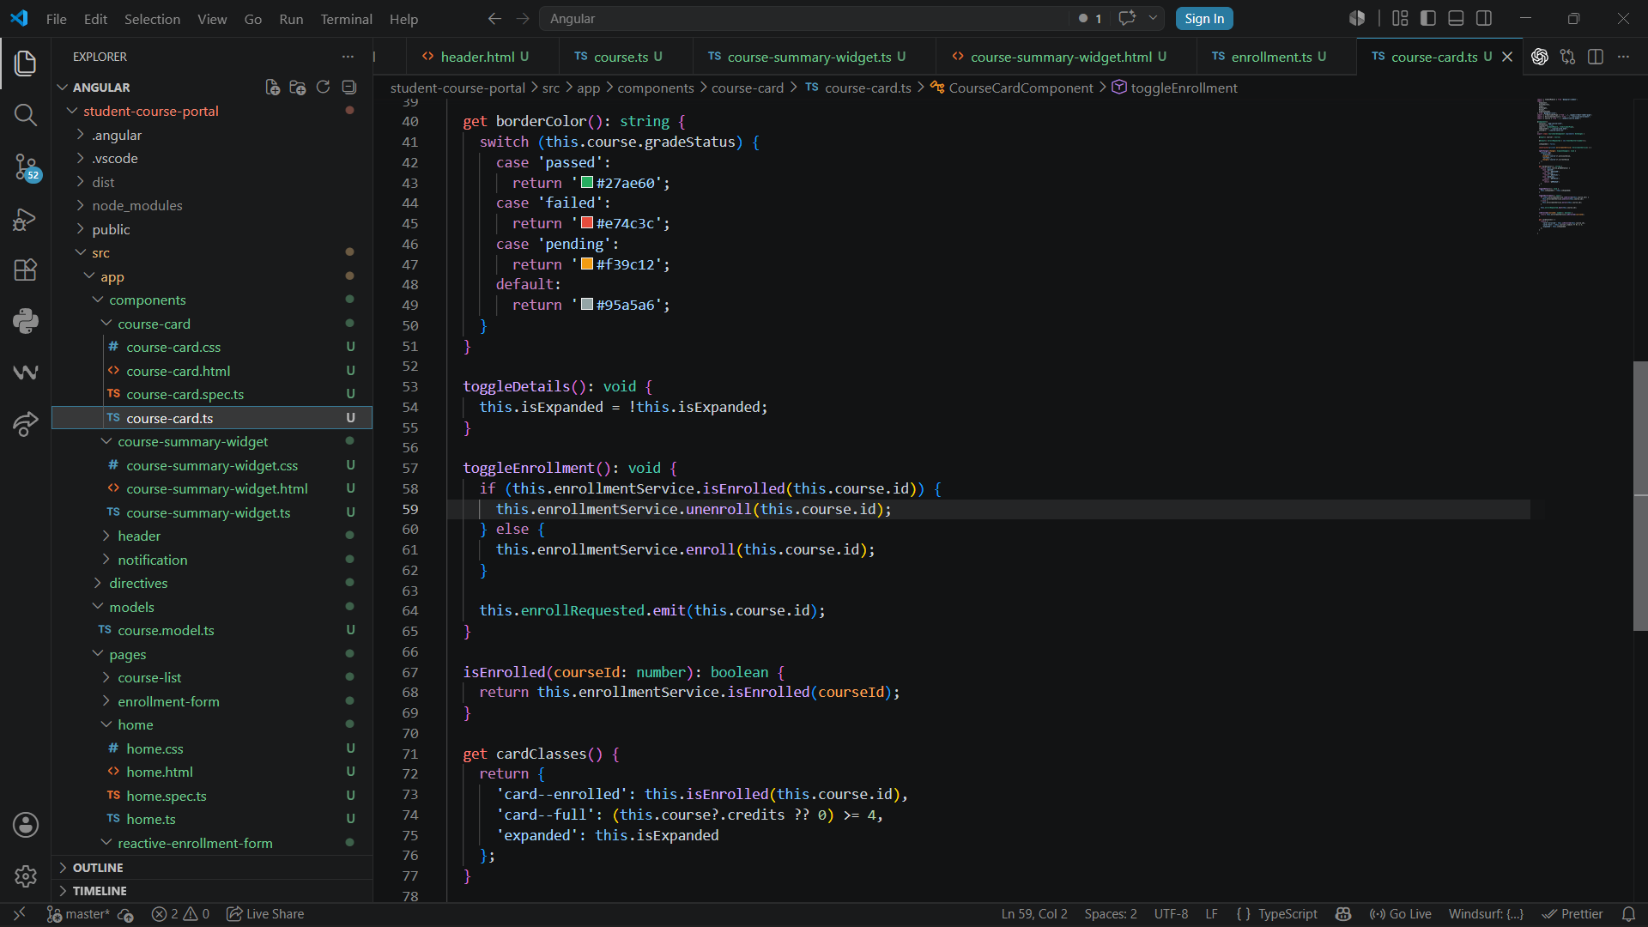
Inclusion of unenroll:
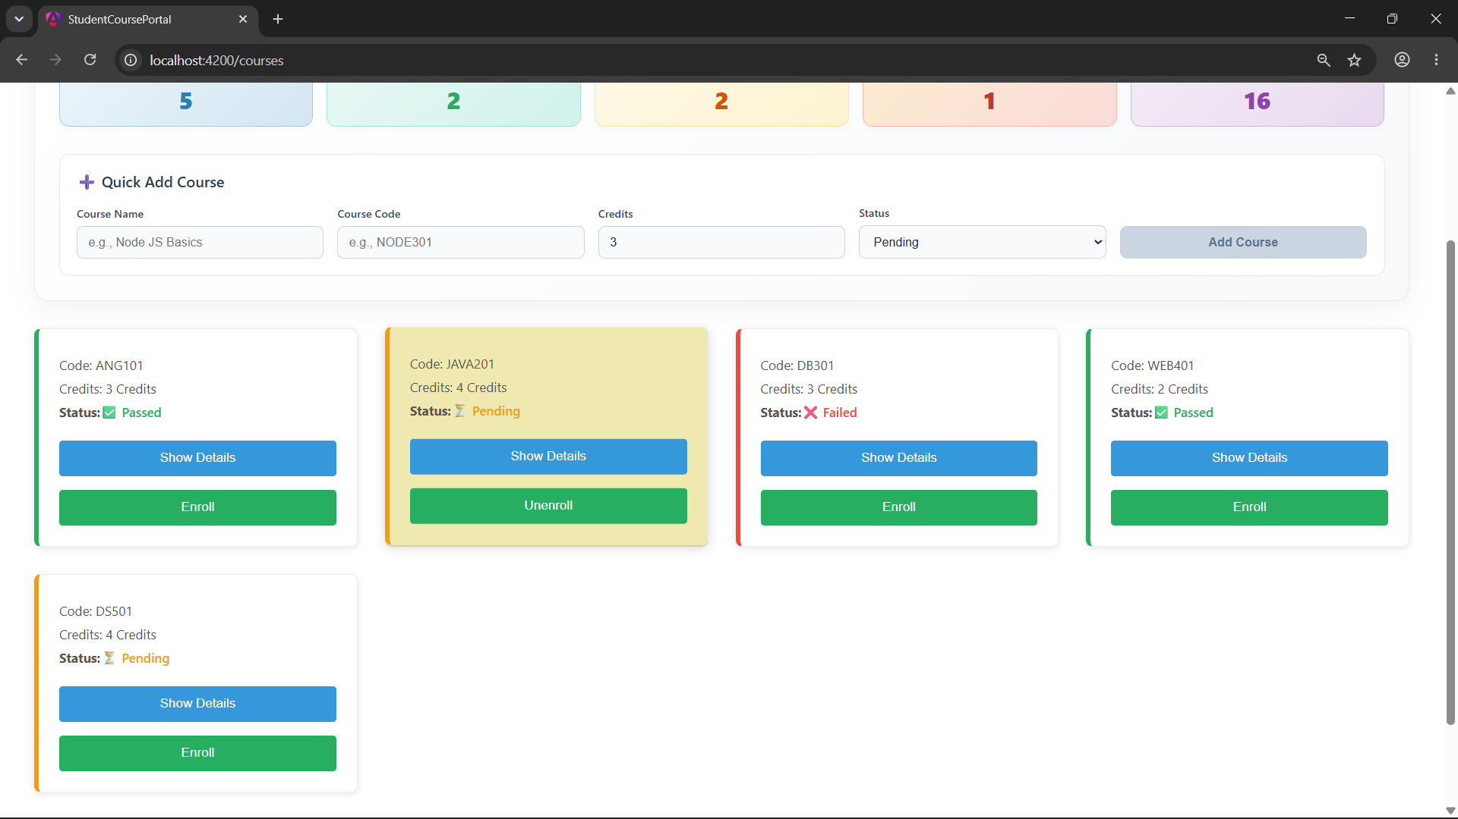

Notification.ts:
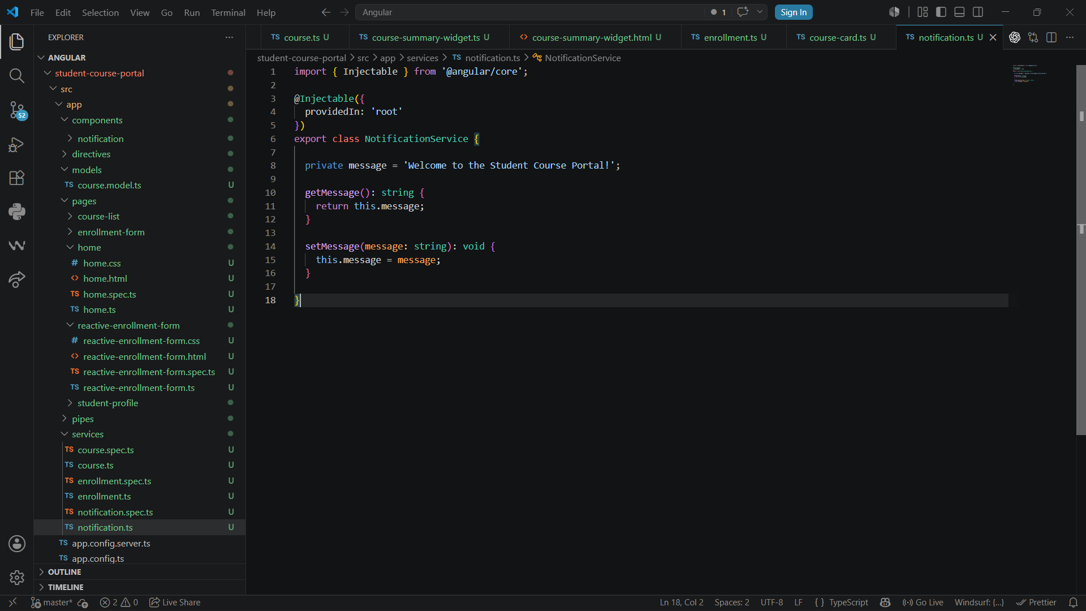
Notification
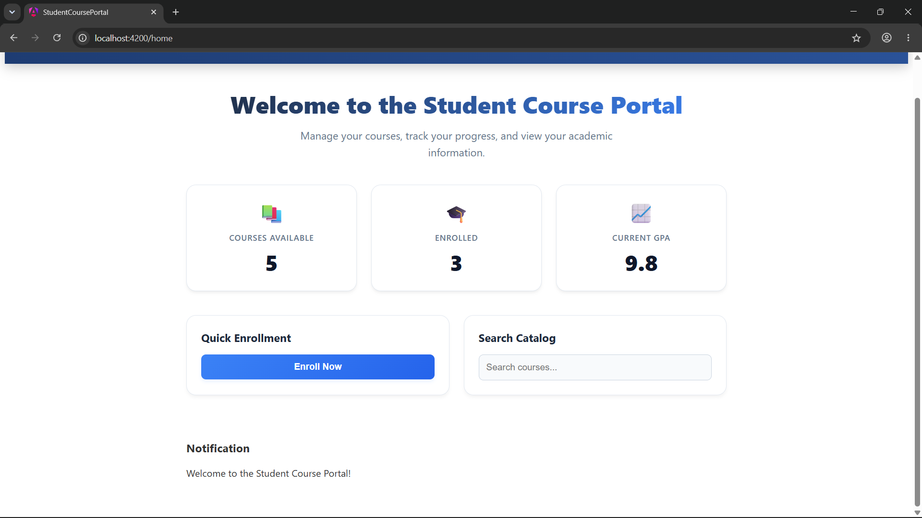

Student-profile.html:
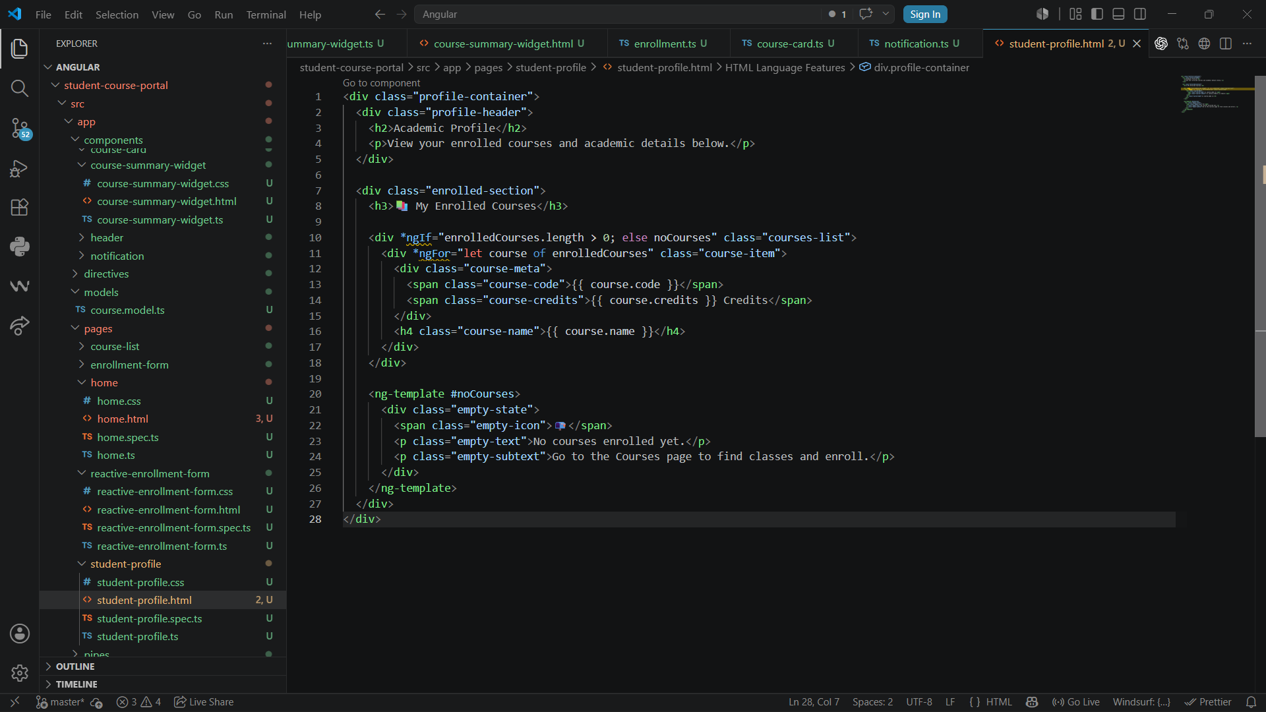
Student-profile.ts:
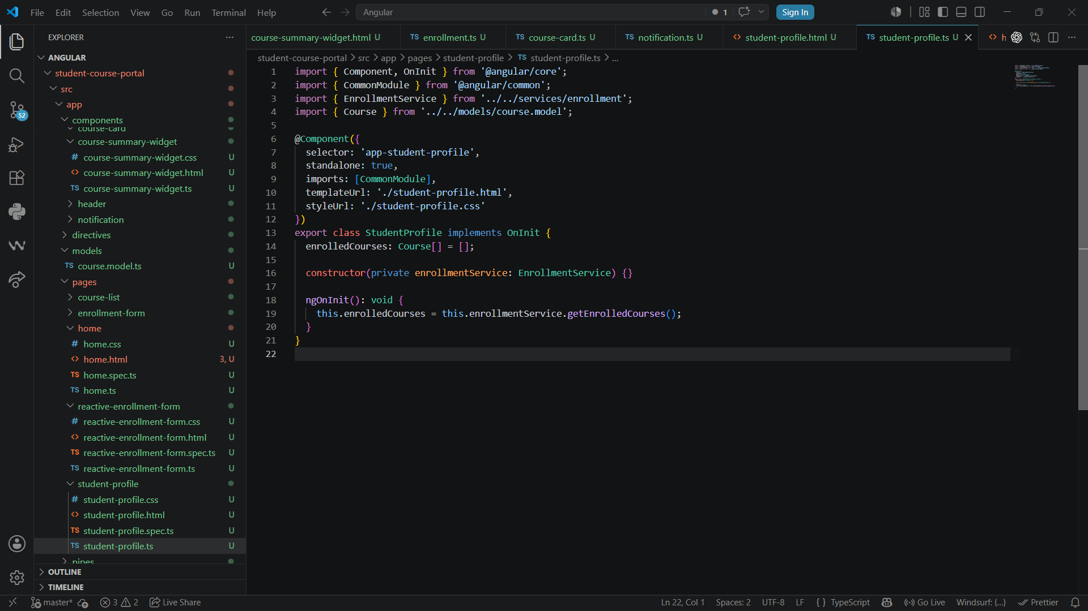

Profile page showing the enrolled course:
